WOOLSTON 6TH FORM COLLEGE  PARENTAL AGREEMENT FOR COLLEGE TO ADMINISTER MEDICINE | 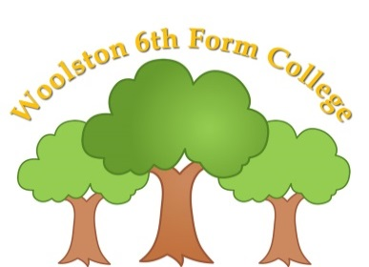

The college will not give your son or daughter medicine unless you complete and sign this form, and the college has a policy that staff can administer medicine when trained to do so.
Name of College | WOOLSTON 6TH FORM COLLEGE
Name of Student
Date of Birth
Form
Medical condition or illness
Medicine
Name/type of medicine
(as described on container)
Date dispensed
Expiry date
Dosage and method ie, syringe, spoon, in a drink
Timing
Special precautions
Are there any side effects that the college needs to know about?
Procedures to take in an emergency
Contact Details
Name
Daytime telephone number
Relationship to Student
Address

I understand that the medicine must be delivered to college by myself or a named responsible adult.
I accept that this is a service that the college is not obliged to undertake.
I understand that I must notify the college of any changes in writing.
Date: ……………………………………………………. Signature: ……………………………………………………..
Reviewed: …………………………………………….

Date:
Time given:
Dose given:
Staff initials:

Date:
Time given:
Dose given:
Staff initials:

Date:
Time given:
Dose given:
Staff initials:

Date:
Time given:
Dose given:
Staff initials:

