WOOLSTON 6TH FORM COLLEGE

PHOTOGRAPHY AND
VIDEO GUIDANCE

Headteachers: Miss Lucinda Duffy & Mr Paul King

Woolston 6th Form College
Woolston Learning Village
Holes Lane
Woolston
Warrington
WA1 4LS

Tel: 01925 811447

Date: January 2019
Review Date: January 2021

PRINCIPLES

This policy details the rules governing photography and recording videos at Woolston 6th Form College, the distribution of these photos and videos, and their publication on the Internet. It covers the rules for staff, governors and parents, and is founded on four main principles:

Safety

The overriding priority is to ensure that photography does not lead, either directly or indirectly, to anything that may potentially endanger the safety of the students at the College.

Privacy

We believe that every student and parent are entitled to their own privacy, and can therefore choose not to feature in photographs or videos recorded at the College.

Projecting the right image

Photographs taken at College should not do anything that may cause embarrassment to the College, the students, or the staff.

Sharing Young Peoples achievements

It is natural for every parent to want to share their young person’s activities and achievements at College with their friends and family. This College is keen to allow this as much as possible, while keeping this in balance with the first three principles.

CONSENT

When a student joins the College, their parents or carers are asked for consent for the student to appear in photos on the College website and the prospectus. The College encourages all parents to provide consent, as it enables us to include all the students in depictions of College life, but we recognise and respect the right to refuse consent. Parents may withdraw consent at any time, or grant consent if they had previously declined. We also request consent for student photos to be included in the newspaper and to be shared with other professionals.

COLLEGE WEBSITE

The College endeavours to publish on the College website a selection of photos of College events and general College life. Any material published to the website must be assessed to ensure it meets the following safeguarding rules:

- It must not feature any student whose parent or carer have not given consent.
- It must not offer any means of identifying a student by their full name.
- It must not in any way embarrass the College or the students and staff involved.

Photos and video intended for the College website should be taken either by a member of staff, or another person authorised by the head teachers. These photos must be approved by the head teachers prior to publication on the website; the mechanism for doing this should be agreed by the head teachers and the photographer.

RULES FOR PARENTS, CARERS AND GOVERNORS

Parents and carers are permitted to take photographs and record videos at designated College events, as long as they agree to the conditions described in this policy and do not unnecessarily disturb or distract others or the event itself.

These events include:

- Aiming High Celebration | - Sports Day
- Christmas events | - College Fayre
- Charity coffee events | - Leavers Assemblies
- Summer Ball | - Enterprise sales

PHOTOGRAPHS FEATURING ONLY YOUR OWN SON/DAUGHTER

There is one exception to the internet publication rule. If the photo/video includes only your own young person, you may share it on the internet. For this exception to apply there must be no other students in shot, however briefly or clearly they can be seen. The reason for this exception is that the College recognises that how you use photos of your own young person is a decision purely for you.

WITHDRAWAL OF PERMISSION

Failure to adhere to these conditions may, at the discretion of the head teachers, lead to a withdrawal of permission to use a camera at future events.

RULES FOR STAFF

- Staff may take photos and video anywhere within the College for the purposes indicated on the parental consent form.
- These may be published to the College website if they conform to the safeguarding rules described above.
- They may not be published on any other Internet or social media site, except those that may be used by the College website.
- They may be stored on password-protected staff laptops. They should be deleted once they are no longer needed, or when the featured students have left the College.
- They may be shared with other members of staff by email to support teaching work. They may not be shared with friends and family.
- The College cameras and I-pads should be used to take photographs where possible. Staff may not use their own mobile phones.
- Members of staff who are also parents or carers of students at the College are permitted to take photographs at College events under the terms described in “rules for parents, carers and governors”.

RULES FOR STUDENTS

- No students are permitted to use personal mobile phones, I pad, I pod or electronic photographic devices to take pictures of other students.
- Students who have their own mobile phones, I pad, I pod or electronic photographic devices in College must leave them in lockers or with a member of staff, unless a member of staff has agreed it’s use within the lesson.
- Any students who have a personal mobile phone, I pad, I pod or electronic photographic devices must sign agreement for acceptable use of mobile phones in College (see Appendix 1).

EXTERNAL PHOTOGRAPHERS

Terms for external photographers, such as local newspapers photographers, must be agreed in advance with the appropriate Head teacher. These are considered on a case-by-case basis, and must conform to the safeguarding rules described above.

Also refer to E-safety policy.

At these events, photos may only be taken at the location of the event. For most of these, this is the College common room. It is not permitted to take photos in form rooms or elsewhere in the College unless explicitly authorized by the Head teachers.

OUTSIDE DESIGNATED EVENTS

It is not permitted to use a camera on College premises at any time outside these designated events unless explicitly authorized by the head teachers.

DISTRIBUTION AND PUBLICATION OF PHOTOS AND VIDEOS

Photos taken at these events are for your own personal use only. They may be shared by email with friends and family, but must not be published on any internet site. This includes Facebook, Twitter, YouTube, Pinterest and all other social media services.

The reason for this restriction is that it is not possible for individual parents to ensure that all four of the safeguarding rules described above are adhered to at both the time of publication, and later.

SHARING PHOTOS ON THE COLLEGE WEBSITE

As described above, the College endeavours to publish a selection of photos from events on the College website. You may share links to these pages on social media services, because any photos or video appearing on the College website will have been checked to ensure they conform to all the safeguarding rules.

You may download the photos from the College website for your own personal use, but you may not republish them anywhere on the Internet.
Appendix 1

ACCEPTABLE USE OF MOBILE PHONES IN COLLEGE BY STUDENTS

- I WILL NOT TAKE PICTURES/VIDEO OF OTHER STUDENTS.

- I WILL NOT USE MY PHONE WHEN IN LESSONS.

- I WILL PUT MY PHONE SAFELY AWAY DURING THE DAY – IN MY LOCKER OR WITH MY TEACHER.

- I AM RESPONSIBLE FOR LOOKING AFTER MY OWN PHONE. COLLEGE IS NOT RESPONSIBLE IF MY PHONE GETS LOST OR BROKEN

Signed ________________________________ Date ____________

ACCEPTABLE USE OF MOBILE PHONES IN COLLEGE BY STUDENTS

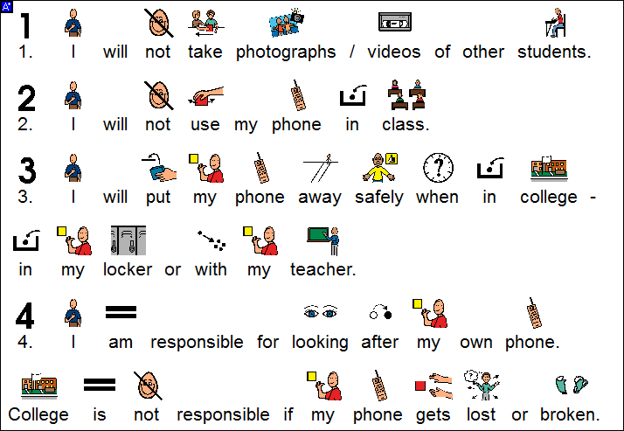

Signed ________________________________ Date ____________

