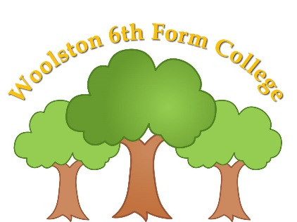

Woolston 6th Form College

COVID 19

HOME / COLLEGE AGREEMENT

The College will:

- Care for your child’s happiness and ensure their safety and mental health is a priority.
- Plan and share with parents the phased expansion of college, based on parental responses.
- Support students in understanding the changes that they are likely to encounter at college, and support students with unplanned changes as they occur.
- Ensure that a suitably trained member of staff is onsite to meet individual students’ needs, or tell you that we are unable to safely support them.
- Be honest with you that Social Distancing is impossible in our college and with our students – we will, however, reduce class sizes and keep students and staff within identified groups, wherever possible.
- Where necessary, amend drop off and pick up times for different groups of students to try to avoid students having to wait in vehicles for too long and to reduce the amount of people walking around at the same time.
- Ensure that students are collected from transport (including family cars) by a member of staff supporting their group.
- Ensure that no visitor, parent or carer comes into the college building unless it is absolutely necessary.
- Ensure that there are thorough cleaning procedures in place as required throughout the day, and by the cleaning team at the end of each day.
- Ensure that there is regular hand washing for all students and adults within the college setting.
- Keep you informed about general college matters through regular letters home and notices about any changes to policy and guidance from the Department for Education, or the Local Authority.
- Send any urgent messages to you via Telephone, Parent Mail or Social Media.
- Respond to parental questions or concerns which are shared via the home/college book, telephone call or emails to college as soon as possible.
- Provide learning opportunities which are built upon those elements that we believe are crucial to their personal development and wellbeing – for students who are in college, and students who continue to learn from home.
- Provide packed lunches for students on site who fall under the Free College Meal scheme, or whose parents pay for this.
- Be honest with you if we are unable to safely staff college, or an individual class, due to staff absence.
- Adopt Warrington Borough Council risk assessments templates, for health & safety within our college buildings and grounds, and ensure that these are read, understood and followed by our staff.
- Follow government guidance around PPE (Personal Protection Equipment) but allow staff to make personal decisions on the wearing of personal face coverings.
- Minimise movement around college, including staggering break times and having lunch within classrooms.
- Practise where classes should stand in the event of a fire drill, ensuring that groups are spaced apart.
- Cancel (or hold online) all non-essential gatherings of staff and students, including assemblies and meetings.
- Cancel or postpone all offsite activities which occur beyond Woolston Learning Village.

Parents/Guardians who require their child to attend college during the Summer Term agree that they will:

- Give at least a week’s notice if I require my child to return to college and work with college around how this can be facilitated safely.
- Return any equipment I have borrowed, to ensure that my child has access to this at college.
- Only send my child into college if they are well and not exhibiting any symptoms related to COVID-19.
- Ensure that if my child has a temperature or is displaying any of the symptoms related to COVID-19, they will self-isolate for 14 days or until test results show a negative result. College must be informed as soon as possible.
- Contact Passenger Transport Team at Warrington Borough Council if my child usually has transport, and I want them to access this. I will direct any questions around transport to this team.
- Ensure that my child is ready when their transport arrives.
- Remain in my car if I need to drop off and pick up, waiting for a member of staff to arrive.
- Maintain the 2 metre social distancing measures when on Woolston Learning Village.
- Ensure that my child arrives at college on time, and leaves college on time, to make sure that any staggered drop offs and pick-ups work for the safety of all students, parents and staff.
- Not come to the college office for any purpose other than if called by college to collect my child.
- Communicate with college staff if I have any concerns or have messages regarding my child, via the home/college book, telephone or email.
- Phone college by 8.30am if my child should be attending college, but will not be coming in.
- Ensure my child comes to college daily in a clean/fresh pair of clothes, including items that are appropriate for the weather.
- Ensure that my child and I follow the social distancing guidelines as set out by the Government.
- Read all information sent from college via letter, email or on the website/social media, and act upon its content.
- Ensure that I am contactable and have arrangements in place so that I can collect my child should they become ill during the college day.
- Look at the menu provided, pay for college lunches if appropriate or provide my child with their own packed lunch.
- Not arrange for any external agencies/staff to visit my child at college, without seeking permission for this from college staff.

