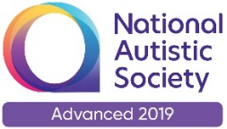 | 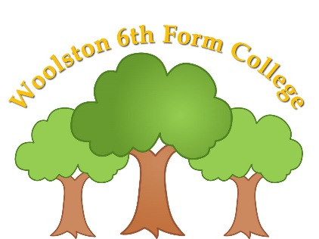  Woolston 6th Form College  Woolston Learning Village  Holes Lane  Woolston  Warrington  WA1 4LS  Tel: 01925 811447  Fax: 01925 852435  Email: woolstonsixthformcollege@warrington.gov.uk

July 2020

Dear Parents/Carers,

I trust this letter finds you well and keeping safe. May I take this opportunity to thank you all for all the help, patience and support that you have offered all of our staff in what has been a very challenging few months for all.

I am very pleased to be writing to let you know that we are planning on opening fully on the 8th of September. The expectation nationally is that all young people will return to school and college in the Autumn term unless they are advised not to by a clinician.

From September, each form group will become a bubble and will follow a class based curriculum. Measures will still be in place to encourage students to socially distance from each other. As far as possible we will try to ensure that students are able to have their own individual resources. Equipment will be regularly cleaned. Our specialist staff will be able to resume working with students on their caseload, delivering for example, SALT, physio and music therapy. Stringent hygiene practices will be in place to reduce any risk.

We will also continue with:

- frequent hand washing and good respiratory hygiene practices (blowing noses into tissues and then putting the tissue straight in the bin after one use)
- regular cleaning of all areas
- limiting the number of classrooms used
- minimising contact and mixing by staggering break times and eating lunch in classrooms
- having PPE available for staff that are carrying out intimate care activities and first aid

When we receive notice that restrictions can be further eased we will revert to our pre-lockdown college curriculum which involves movement of students to different rooms, working with different staff and students during specific sessions.

We have updated the risk assessments of the site, the building, the classrooms and the processes that go on in college. These assessments will be reviewed regularly so they remain accurate.

If your son/daughter has a temperature or is displaying any of the symptoms related to COVID-19, they should self-isolate for 14 days or until test results show a negative result. College must be informed as soon as possible. If they display these symptoms whilst at college we will contact you straight away so you can collect your son/daughter.

Free school meals will be provided for those entitled. If you are not entitled to a free school meal then you can purchase a lunch or bring your own. The lunch that is available to purchase will continue to be a hot packed lunch.

The times of the college day will remain from 9am to 3.15pm unless you are notified otherwise. Transport times may be altered due to buses/taxis needing to make more than one journey due to social distancing measures. You will be notified by transport if that is the case. For those parents dropping off and picking up themselves, please continue to wait in the car until college staff come out to you. We will do this as quickly as we can but would appreciate patience until we adapt to these new routines.

We also ask that, if possible, snack money comes in half termly, rather than weekly. This is to limit how often Maree handles cash. Autumn 1 is 7 weeks long so we ask for £14 please.

Please also read the home/college agreement. This has been written with the sole intention of protecting students, families and staff whilst providing the best possible education and learning experiences that we can for all.

We will continue to follow local and national guidance around any future Covid-19 outbreaks and respond accordingly.

If you would like to discuss any of the issues raised in this letter then please contact college.

Many thanks again and have a great summer!

Yours sincerely

Lynne Ledgard
Woolston 6th Form College

