Using Clicker 7

Clicker 7 is a very versatile program and very easy to use. If you have a pc load the program and use the licence key on the letter we have sent to you to activate the program.
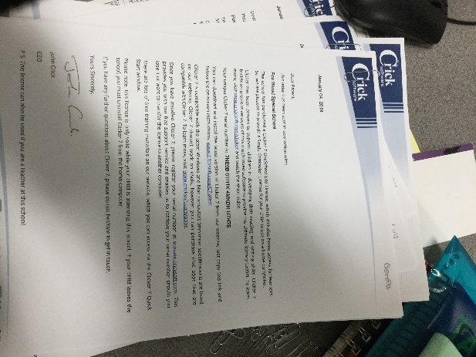

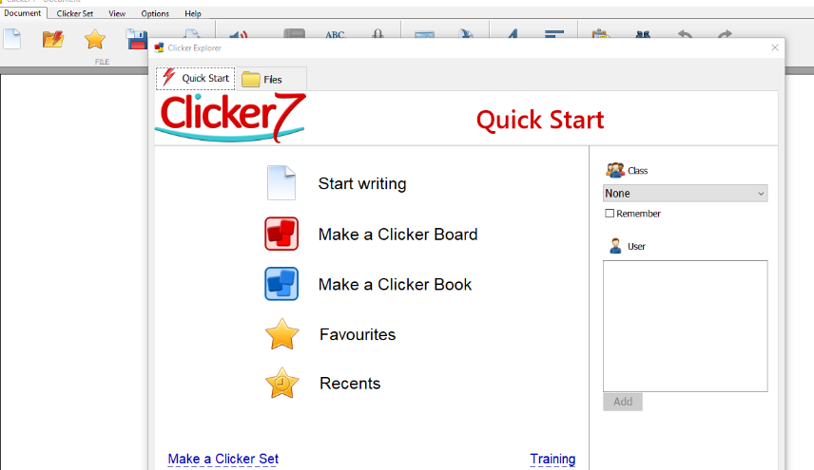
When you load the program this is what you will see. Click this corner to close top sheet.

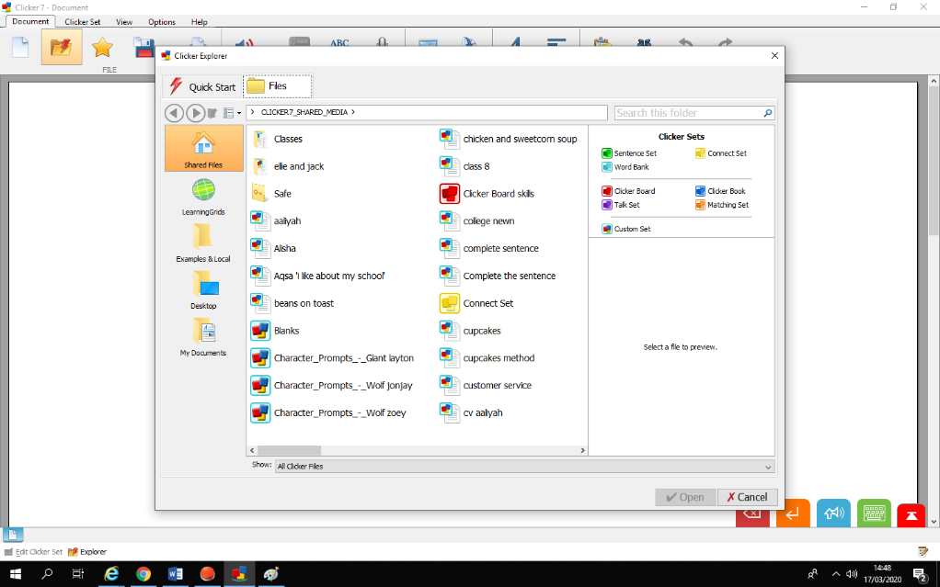
Now click this, then this. It will then tell you it is connecting to Learning grids.

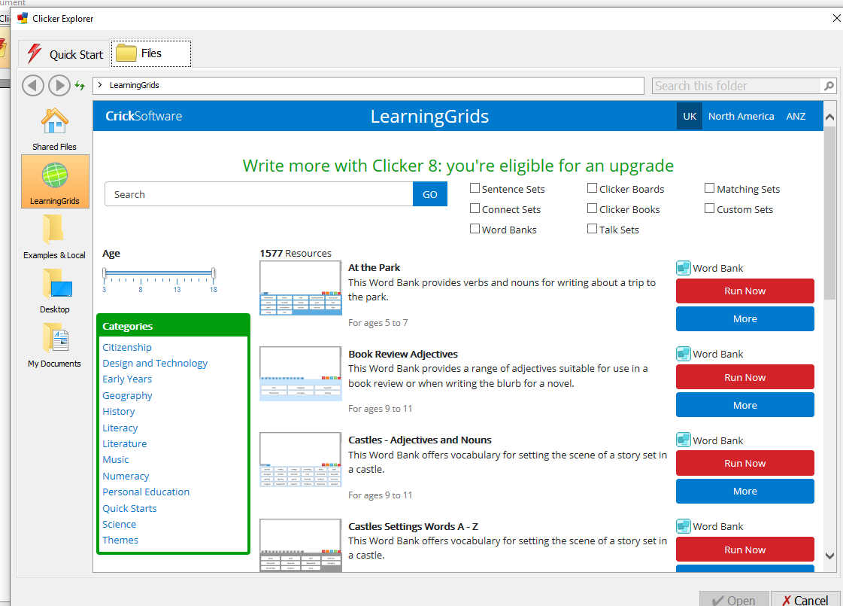
Type into the search box your child’s topic and resources will appear. Then just click Run now. The resource will open
Once open your child can complete the activity with you and then independently. Feel free to adjust adapt any resources you find for your child/children
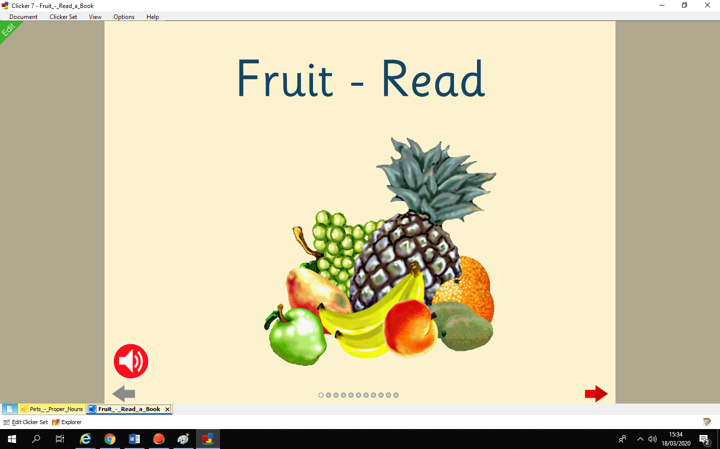

There are loads and loads of activities please explore and have fun.

The help files are excellent and can be found here. You can’t break the program so have a play.
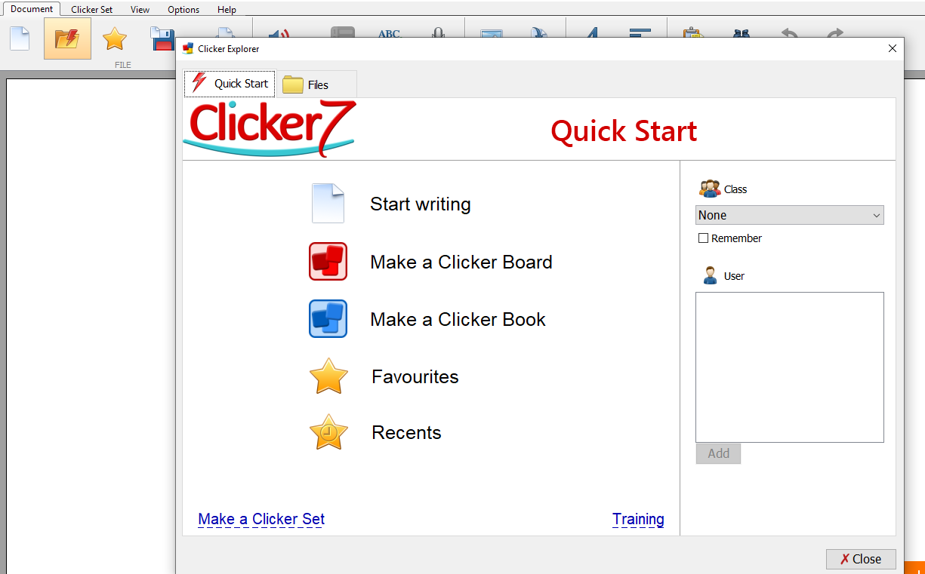

.

We would love to see any resources or activities you make. Please load up any work activities to EFL

